Link
https://employee.cmhlmc.com/employee-account/?id=0&view=employee%2Fchange-password

Criditional :
Employee ID 0001-23228 password: 1213454

Issue:
While clicking on Icon back linking is not working.

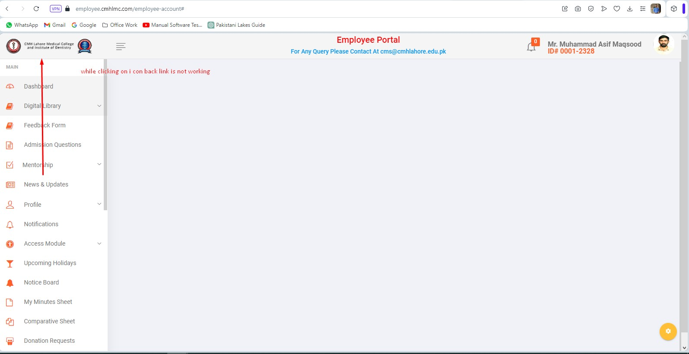

Link
https://employee.cmhlmc.com/employee-account/?id=0&view=employee%2Fchange-password

Criditional :
Employee ID 0001-23228 password: 1213454

Issue:
Readability issue A normal user can not find how to close the side Bar window

